Nexora insights and reporting
Document 19 of the Nexora learning guides
Source snapshot 13 October 2026 at 17:12 UTC
Understand dataset selection, query filters, matching totals, paging and CSV export.

Recognise the screen and its scope
Open /insights. CRM routes use port 3017; member routes use 3018; public website routes can use 3019. Brackets name a route parameter, not text to paste into a browser. Choose a real record or site id from the application.
This guide covers Available datasets; Search exact status and created-date filters; Server query paging; Sorting; CSV export; Tenant and role restrictions.
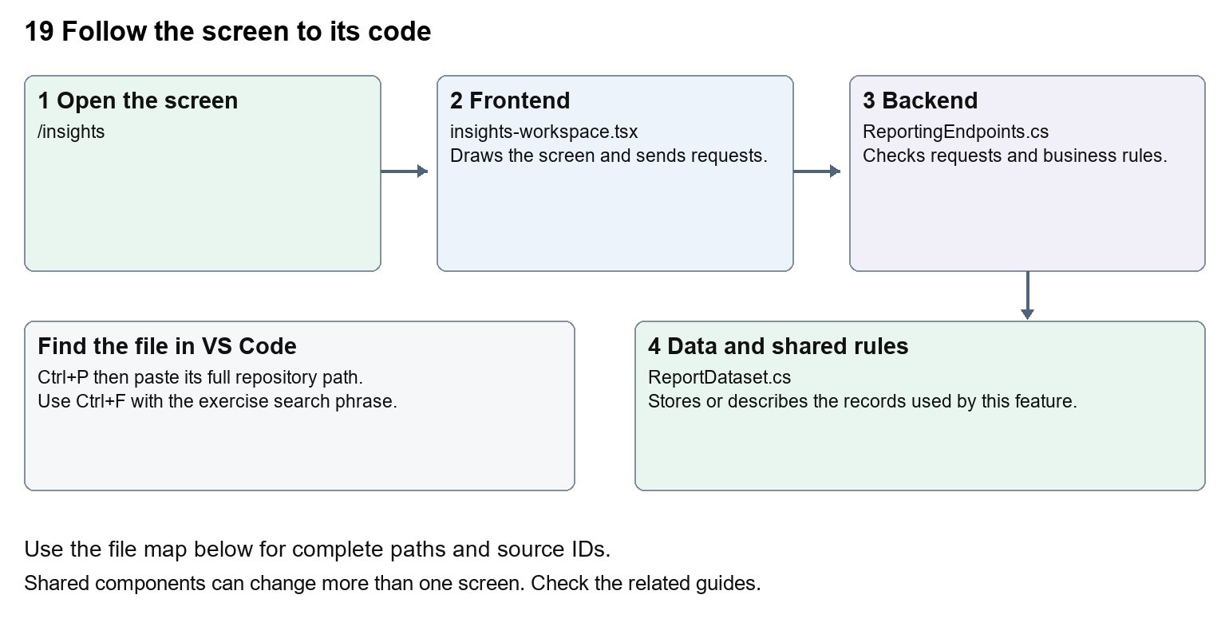
The diagram shows the file roles. The full paths below are what you paste into Ctrl+P.

Find the files in VS Code
Role | File and source ID | What it does
Screen | S0099 insights-workspace.tsx | Main UI or route for this topic
Server | S0577 ReportingEndpoints.cs | Endpoints or server rules
Data | S0199 ReportDataset.cs | Data shape or persistence structure

Screen S0099
apps/web/src/features/insights/insights-workspace.tsx
Server S0577
backend/src/Nexora.Api/ReportingEndpoints.cs
Data S0199
backend/src/BuildingBlocks/Nexora.BuildingBlocks/Reporting/ReportDataset.cs
The complete HTML manual opens these source IDs inside its Source library. The Word manual shows short labelled extracts so you can learn the flow before reading large files. Each individual Markdown guide includes its complete primary files after the walkthrough.

Follow the request and the records
1. Insights asks the API for datasets permitted to the signed-in user.
2. The user selects a dataset and enters filters.
3. A POST query request applies those filters on the server.
4. The response supplies total and current page items.
5. Export requests the permitted matching records with the same intended filter scope.

Read the code with an explanation
A dataset describes how a module exposes reportable records. The browser has filter state and query state; pressing Run report commits the chosen filter values to a request. Previous and Next change skip while keeping the query. Total is the full matching count, while items is one page. Permission checks protect both queries and exports.
Source reference S0099 apps/web/src/features/insights/insights-workspace.tsx
Selected opening lines with their original numbers. The complete file is in the HTML source library.
0001 "use client";
0002 import { EntityHeading } from "@/components/ui/entity-heading";
0003 import {useEffect,useState} from "react";
0004 import {moduleApi} from "@/features/shared/module-api";
0005 import { ColumnChooser } from "../shared/column-chooser";
0006 import { FilterViewToolbar } from "../shared/filter-view-toolbar";

The import lines lead to shared components and helpers. Start at the exported component or route function; follow the request helper to the server rather than assuming the whole feature lives in this file.
Source reference S0577 backend/src/Nexora.Api/ReportingEndpoints.cs
Extract from source line 12. A fragment from a long line is shown without the rest of that line.
0012 api.MapGet("/datasets",(IEnumerable<IReportDataset> datasets,HttpContext http)=>datasets.Where(d=>Allowed(http,d)).Select(d=>new{d.Key,d.Title,fields=new[]{"label","status","createdAtUtc"}}));

On the server, look for MapGet to load records, MapPost to create or perform an action, MapPut or MapPatch to change data, and RequireAuthorization for permissions. Some shared methods register endpoints indirectly. Find SaveChangesAsync to see the database write. A request method alone does not tell you every side effect.
Source reference S0199 backend/src/BuildingBlocks/Nexora.BuildingBlocks/Reporting/ReportDataset.cs
Selected opening lines with their original numbers. The complete file is in the HTML source library.
0001 using Microsoft.EntityFrameworkCore;
0002 namespace Nexora.BuildingBlocks.Reporting;
0003 public sealed record ReportQuery(string? Search=null,string? Status=null,DateTime? FromUtc=null,DateTime? ToUtc=null,int Skip=0,int Take=50,string Sort="-createdAtUtc");
0005 public sealed record ReportPage(int Total,IReadOnlyList<ReportRow> Items);
0006 public interface IReportDataset
0007 {

Follow model fields to their request names and database mapping. An id points to a particular record. A tenant id limits the organisation. A version or concurrency stamp protects newer edits. Some model files describe contracts rather than tables; check the owning DbContext before assuming storage.

Make or trace your first change
1. Press Ctrl+P and open apps/web/src/features/insights/insights-workspace.tsx.
2. Press Ctrl+F and search for Explore records available to your tenant and role. Counts reflect the time this page loaded.. In this snapshot it appears at line 19.
3. Replace only this paragraph text. Run the same report before and after the change and check the total and results do not change because of the wording.
4. Replace only Explore records available to your tenant and role. Counts reflect the time this page loaded. with Explore the records your organisation and role can access. Counts show this page load. in that intended location. Keep quotes, tags, JSON keys and routes intact.
5. Save with Ctrl+S. Inspect Problems and the local screen. Review the diff and restore the original text when you finish practising.
Extract from source line 19. A fragment from a long line is shown without the rest of that line.
0019 ding><p className="text-slate-600">Explore records available to your tenant and role. Counts reflect the time this page loaded.</p>{error&&<p role="alert" className="text-r

These exercises have not been applied to the application. Their search phrases are verified against the captured source. Line numbers can move; the phrase and file path are your main navigation aids.

Check a change and diagnose problems
Confirm the original screen still loads, the changed words appear in the intended place, and another screen using the same component still behaves correctly. If an action fails, inspect the browser Network response, the relevant helper and server validation message. Use the common error table at the beginning of the manual. Reload on a version conflict instead of removing the version check.
A syntax error after a text edit usually means a quote, brace or closing tag changed. Compare your diff with the original. An unchanged browser result can mean the wrong port, a saved published configuration overriding a default, or a running API that has not reloaded.

Understand the current limits
An Insights count measures stored records available to that role. It does not establish external analytics integration or broader commercial KPIs. Export rights are separate from read rights.

Continue learning
Related guides 04 Nexora home dashboard, 07 Nexora record listings and saved views, 15 Nexora sales and finance, 18 Nexora imports exports and migration.

